Project: NGINX Load Balancer (Terraform)
Table of Contents
Project: NGINX Load Balancer (Terraform) 1
Objective 1
Prerequisites 2
Architecture diagram 3
Terraform architecture 3
Project directory structure 4
Modular Structure 4
Notes and operational tips 5
Implementing Infrastructure with Terraform 5
1. Configure the Backend 5
Step 1: Create an Amazon S3 bucket 5
Step 2: Define the backend configuration file (backend.tf) 6
2. Create Root Module 6
File: main.tf 6
File: provider.tf 7
File: variables.tf 7
File: terraform.tfvars 7
File: outputs.tf 8
3. Module Implementation 8
modules/network 8
modules/security 8
modules/ec2 9
4. Running Terraform 9
5. Cleanup 10
NGINX Configuration and Load Balancing Setup 10
Backend EC2 Configuration (Private Instances) 10
Steps 11
Load Balancer EC2 Configuration (Public Instance) 11
Configuration File Path 11
Configuration Summary 11
Explanation 12
Testing the Load Balancing Setup 13
Steps to Test 13
Expected Outcome 13

Objective
Deploy a simple NGINX load-balancer architecture on AWS using Terraform. The deployment creates a VPC, a public subnet with a load-balancer EC2 instance, a private subnet with two backend EC2 instances, routing (IGW + NAT), and security groups that limit access. The load balancer forwards HTTP traffic to the backends. Terraform state is stored in an S3 bucket.

Prerequisites
Before you begin, ensure you have the following:
- An AWS account with permissions to create VPCs, EC2 instances, IAM roles (if needed), Elastic IPs, NAT Gateways, and S3 buckets.
- AWS CLI installed and configured with a profile that has the required permissions:
aws configure --profile default
- Terraform installed (v1.3.0 or later recommended).
- A pre-created EC2 key pair (for SSH) in the target region. You must know the key name (example: wu-key).
- An S3 bucket created in the same region to store Terraform state (you will provide its name in backend.tf).
- Basic familiarity with Terraform modules, variables, and the terraform lifecycle (init, plan, apply, destroy).

Architecture diagram
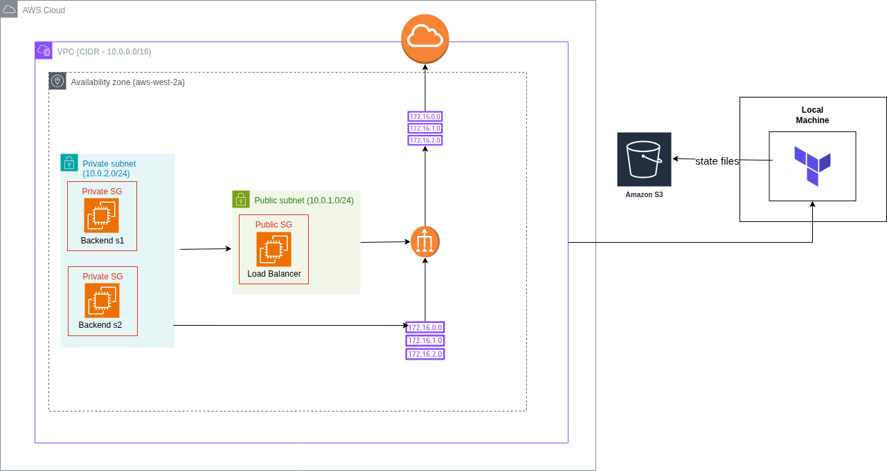

- A single VPC (10.0.0.0/16) contains two subnets in one AZ (us-west-2a):
  - Public subnet (10.0.1.0/24) hosts the Load Balancer EC2. The subnet attaches to an Internet Gateway (IGW) to accept external traffic.
  - Private subnet (10.0.2.0/24) hosts two backend EC2 instances. These instances do not have public IPs.
- NAT Gateway in the public subnet with an Elastic IP provides outbound internet access for private instances (for package installs in user-data).
- Security groups:
  - Public SG allows HTTP/HTTPS from the internet and SSH from your admin IP.
  - Private SG allows inbound HTTP/SSH only from the public SG.
- Terraform runs from your local machine and stores its remote state file in an S3 bucket. The S3 backend keeps state centralized and safe for collaboration.

Terraform architecture
This project uses a modular, opinionated layout. Each module encapsulates one area of responsibility so you can reuse, test, and maintain parts independently.
High-level flow:
- network module creates VPC, subnets, IGW, NAT GW, route tables, and associations.
- security module creates security groups for public (load balancer) and private (backends).
- ec2 module provisions one public EC2 (load balancer) and two private EC2s (backends), and injects simple user-data to install NGINX.
- Root module wires modules together, provides variable values, and configures the S3 backend for remote state.
Design goals:
- Single AZ deployment (us-west-2a) simple and deterministic for labs.
- Explicit private IPs for backend instances (you can change them).
- NAT Gateway ensures private nodes can fetch packages during provisioning.
- Minimal, clear outputs for quick verification (LB public IP, backend private IPs, VPC/subnet IDs).

Project directory structure
aws-lb-infra/
├── backend.tf # backend S3 configuration
├── main.tf # root module: calls network, security, ec2 modules
├── provider.tf # provider and required_providers
├── variables.tf # root-level variables and defaults
├── terraform.tfvars # environment-specific values
├── outputs.tf # root-level outputs (LB IPs, subnet ids)
└── modules/
├── network/
│ ├── main.tf
│ ├── variables.tf
│ └── outputs.tf
├── security/
│ ├── main.tf
│ ├── variables.tf
│ └── outputs.tf
└── ec2/
├── main.tf
├── variables.tf
├── outputs.tf
├── userdata-lb.sh # installs nginx on LB
└── userdata-backend.sh # installs nginx on backend

Modular Structure
- modules/network
  - Inputs: VPC CIDR, public/private subnet CIDRs, AZ, env tag.
  - Creates: VPC, single public subnet, single private subnet, IGW, Elastic IP, NAT Gateway, public/private route tables and associations.
  - Outputs: vpc_id, public_subnet_id, private_subnet_id, igw_id, nat_id, route table ids.
- modules/security
  - Inputs: vpc_id, env_tag, my_ip (for admin SSH).
  - Creates: Public security group (open 80/443 to internet, SSH from your IP) and Private security group (allow HTTP/SSH only from public SG).
  - Outputs: public_sg_id, private_sg_id.
- modules/ec2
  - Inputs: subnet IDs, key name, instance type, AMI owner, SG IDs, env tag.
  - Creates:
    - lb (public EC2): installs NGINX via userdata-lb.sh, has public IP.
    - backend1 and backend2 (private EC2s): installs NGINX via userdata-backend.sh, assigned chosen private IPs, no public IPs.
  - Outputs: lb_public_ip, backend_private_ips.

Notes and operational tips
- Use terraform state list to inspect what Terraform currently manages.
- Use terraform destroy to tear down all resources when you’re done; remember that NAT Gateways and EIPs incur cost while running.
- Keep the S3 bucket used for state private. Enforce encryption and restrict access to the team.
- If you change backend.tf after initial init, rerun terraform init and follow prompts to migrate state.
- If you need to change private IPs for backends, update variables and terraform plan Terraform will attempt to change instance network settings (validate plan carefully).

Implementing Infrastructure with Terraform

1. Configure the Backend

Step 1: Create an Amazon S3 bucket
Before running Terraform, manually create an S3 bucket in the same region (for example, us-west-2).
This bucket securely stores the Terraform state file.
Using a remote backend in S3 is considered best practice for production environments because it:
- Enables team collaboration.
- Protects state consistency.
- Provides durability and versioning.
- Keeps sensitive infrastructure data out of local machines.

Step 2: Define the backend configuration file (backend.tf)
Add a file named backend.tf in the project root.
Replace the placeholder values with your actual S3 bucket name and desired key path.
terraform {
backend "s3" {
bucket = "my-tf-state-bucket" # Replace with your bucket name
key = "loadbalancer/terraform.tfstate"
region = "us-west-2"
encrypt = true
}
}

2. Create Root Module

File: main.tf
This file ties together all the modules and controls the overall workflow.
module "network" {
source = "./modules/network"
vpc_cidr = var.vpc_cidr
public_subnet_cidr = var.public_subnet_cidr
private_subnet_cidr = var.private_subnet_cidr
az = var.az
env_tag = var.env_tag
}

module "security" {
source = "./modules/security"
vpc_id = module.network.vpc_id
env_tag = var.env_tag
my_ip = var.my_ip
}

module "ec2" {
source = "./modules/ec2"
subnet_public_id = module.network.public_subnet_id
subnet_private_id = module.network.private_subnet_id
key_name = var.key_name
instance_type = var.instance_type
env_tag = var.env_tag
ami_owner = var.ami_owner
public_sg_id = module.security.public_sg_id
private_sg_id = module.security.private_sg_id
}
Purpose:
- Calls three child modules: network, security, and ec2.
- Passes inputs (CIDRs, key name, AMI owner, IP address) to ensure reproducibility.
- References outputs from one module (like vpc_id) into another.
- Serves as the main entry point for all Terraform actions.

File: provider.tf
This file defines the AWS provider and its version requirements.
terraform {
required_version = ">= 1.3.0"
required_providers {
aws = {
source = "hashicorp/aws"
version = ">= 4.0"
}
}
}

provider "aws" {
region = var.region
profile = "default"
}
Purpose:
- Ensures you use compatible Terraform and AWS provider versions.
- Loads credentials from the default AWS CLI profile.
- Sets the region dynamically using a variable.

File: variables.tf
Defines all top-level configurable inputs. Example contents:
variable "region" {}
variable "vpc_cidr" {}
variable "public_subnet_cidr" {}
variable "private_subnet_cidr" {}
variable "az" {}
variable "env_tag" {}
variable "key_name" {}
variable "instance_type" {}
variable "ami_owner" {}
variable "my_ip" {}
Purpose:
Allows flexible deployments by reading environment-specific values from terraform.tfvars.

File: terraform.tfvars
Create this file to store your environment-specific parameters.
Do not include secrets, and never commit this file to public repositories.
Example fields to include:
region = "us-west-2"
vpc_cidr = "10.0.0.0/16"
public_subnet_cidr = "10.0.1.0/24"
private_subnet_cidr = "10.0.2.0/24"
az = "us-west-2a"
env_tag = "sandbox"
key_name = "your-keypair-name"
instance_type = "t3.micro"
ami_owner = "amazon"
my_ip = "your.public.ip.address/32"

File: outputs.tf
Provides easy access to key resource IDs and connection details after provisioning.
output "lb_public_ip" {
description = "Public IP of the NGINX load balancer"
value = module.ec2.lb_public_ip
}

output "backend_private_ips" {
description = "Private IPs of backend servers"
value = module.ec2.backend_private_ips
}
Purpose:
- Makes it easy to reference deployed resources directly after apply.
- Supports future integration with other tools or pipelines.

3. Module Implementation
You can refer to the code of the respective modules inside the repository.

modules/network
Purpose: Build all networking components.
Creates:
- VPC
- One public and one private subnet
- Internet Gateway
- NAT Gateway (with EIP)
- Route tables and associations
Outputs:
- vpc_id, public_subnet_id, private_subnet_id, nat_id, igw_id.
Logic:
Every EC2 instance must live in a subnet inside a VPC. Public subnets use the IGW for inbound/outbound internet access; private subnets use NAT for outbound traffic (e.g., downloading NGINX packages).

modules/security
Purpose: Create security groups for the public load balancer and private backend servers.
Public SG:
- Allows inbound HTTP (80), HTTPS (443) from anywhere.
- Allows SSH (22) only from your IP (my_ip variable).
Private SG:
- Allows inbound HTTP and SSH only from the Public SG.
Logic:
Defines least-privilege access:
- Public instance is internet-reachable.
- Private instances are shielded from the internet, accessible only through the load balancer.

modules/ec2
Purpose: Provision EC2 instances and run installation scripts automatically.
Creates:
- One public EC2 instance (Load Balancer) with a public IP.
  - User data installs NGINX (later you’ll configure reverse proxy and load balancing).
- Two private EC2 instances (Backends).
  - User data installs NGINX as a basic web server for future load-balancing tests.
Logic:
Demonstrates a real-world scenario with a public-facing NGINX front end and private backend servers.
User data runs automatically on first boot, ensuring consistent, repeatable setups.
Example userdata-backend.sh (simplified):
#!/bin/bash
yum update -y
yum install -y nginx
systemctl start nginx
systemctl enable nginx
Example userdata-lb.sh (simplified):
#!/bin/bash
yum update -y
yum install -y nginx
systemctl start nginx
systemctl enable nginx

4. Running Terraform
Run these commands from the project root. Each command purpose is shown.
- Initialize the working directory and configure the backend
terraform init
  - Download providers and modules.
  - Initialize the S3 backend (if backend.tf is present). If you just added backend.tf or changed backend config, Terraform may prompt to migrate state, confirm the migration if prompted.
- Validate configuration files
terraform validate
  - Check that the configuration is syntactically valid and internally consistent.
- Create and review an execution plan
terraform plan -out=tfplan
  - Generate an execution plan and save it to tfplan.
  - Review the plan output carefully. Look for any unexpected destroy actions or resource replacements.
- Apply the saved plan
terraform apply "tfplan"
  - Apply the exact plan you reviewed. Terraform will provision resources in the correct order and display outputs when complete.
  - If you prefer an interactive plan (without saved plan file), run terraform apply directly and confirm.

NGINX Configuration and Load Balancing Setup
To configure the NGINX web servers on the private backend EC2 instances and the public load balancer EC2 instance so that the load balancer distributes HTTP requests evenly between both backend servers using the Round Robin algorithm.

Backend EC2 Configuration (Private Instances)
Each backend EC2 instance hosts a simple NGINX web server that returns a unique HTML response.
This helps visually confirm load balancing during testing.

Steps
- Connect to each backend instance
Since the backend instances are in a private subnet, you have to first ssh into the public ec2 and then access the backend ec2 from there:
ssh -i <your-key.pem> ec2-user@<backend-private-ip>
- Navigate to the NGINX root directory
cd /usr/share/nginx/html
- Modify the default index.html
  - On Backend 1 (10.0.2.100), edit the file (write text for backend server identification):
<h1>Welcome from Backend Server 1</h1>
  - On Backend 2 (10.0.2.101), edit the file:
<h1>Welcome from Backend Server 2</h1>
- Restart NGINX
sudo systemctl restart nginx
Explanation:
These two backend servers represent independent application instances running in a private subnet.
Each responds differently so that the load balancing behavior can be visually confirmed when requests are distributed across them.

Load Balancer EC2 Configuration (Public Instance)
The public EC2 instance acts as an NGINX load balancer.
Incoming traffic from the internet is routed to this instance and then distributed across the backend servers inside the private subnet.

Configuration File Path
/etc/nginx/nginx.conf

Configuration Summary
Edit the default nginx.conf file and add the following code :
# NEW: Define upstream backend servers (Round Robin by default)
upstream backend {
server 10.0.2.100; # NEW - backend server 1
server 10.0.2.101; # NEW - backend server 2
}

# NEW: Configure load balancer server block
server {
listen 80;
listen [::]:80;
server_name _;

location / {
proxy_pass http://backend; # NEW - forward traffic to upstream group
proxy_set_header Host $host; # NEW
proxy_set_header X-Real-IP $remote_addr; # NEW
proxy_set_header X-Forwarded-For $proxy_add_x_forwarded_for; # NEW
proxy_set_header X-Forwarded-Proto $scheme; # NEW
}

Explanation
- upstream backend {} — defines a group of backend servers for load balancing; NGINX uses Round Robin by default.
- server 10.0.2.100 / 10.0.2.101 — specify the private IPs of backend EC2 instances.
- server { listen 80; } — sets up the public EC2 (load balancer) to accept HTTP traffic on port 80.
- proxy_pass http://backend; — forwards all incoming requests to the upstream backend group.
- proxy_set_header Host $host; — passes the original host header to the backend servers.
- proxy_set_header X-Real-IP $remote_addr; — sends the real client IP to the backend (for logging).
- proxy_set_header X-Forwarded-For / X-Forwarded-Proto — maintain the full chain of client request details and original protocol.

Testing the Load Balancing Setup
Once configuration is complete, the system can be tested to verify round-robin load distribution.

Steps to Test
- Retrieve the public IP of the load balancer EC2 instance:
terraform output public_lb_ip
- Open the IP address in a browser:
http://<public-ip>
- Refresh the page multiple times.
  - The response should alternate between:
    - Welcome from Backend Server 1
    - Welcome from Backend Server 2

Expected Outcome
- Each refresh or request shows responses from different backend servers in rotation.
- This confirms that the NGINX load balancer is functioning correctly using the Round Robin method.

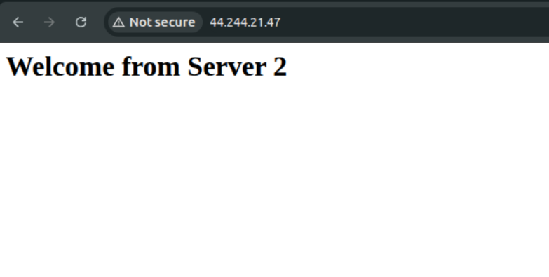
Cleanup
When finished, destroy resources to prevent unwanted charges:
terraform destroy
Confirm when prompted. This removes all resources created by the configuration, including NAT Gateway and Elastic IP (which are billable).

